**Market status and**

**All about A.I**

**ICT융합학부 2017012906 박지용**

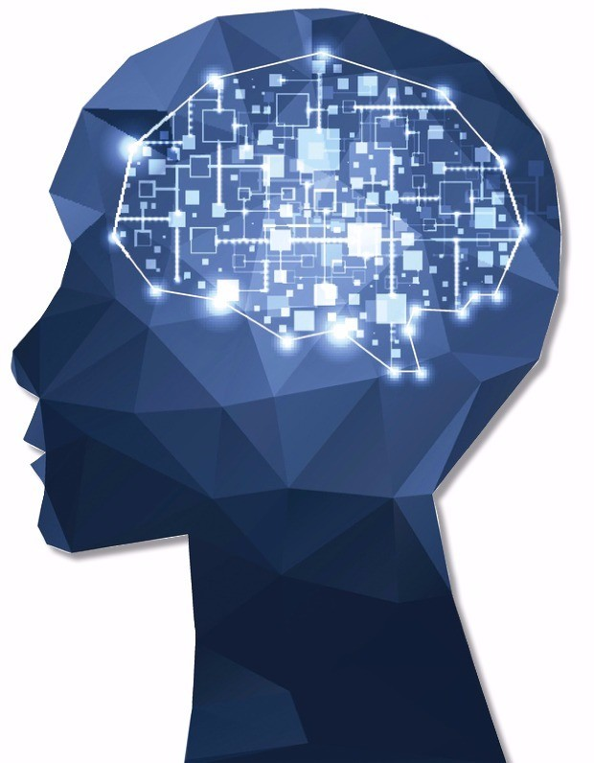

**Contents**

**1. Introduction**

**2. About A.I technology**

**3. A.I ’s past and expected future**

**4. Market status of A.I technology**

**4-1. In Health Care**

**5. A.I ’s expected dangerousness**

**1. Introduction**

Today, A.I, The artificial intelligence is becoming a hot topic. A.I technology means making intelligence that human have by imitating artificially. A.I can collects a lot of information -such as emails, SNS, even privacy, and etc- even if you don’t know and can make the most reasonable choice based on collected data, Called ‘Big Data’. These facts make company focused on new hot technology, A.I. To grow own company more bigger, stronger and not to lag behind other competitors, company’s CEOs should accept A.I technology. From now, main point of operating the company will be changed to Artificial Intelligence technology.

**2. About A.I technology**

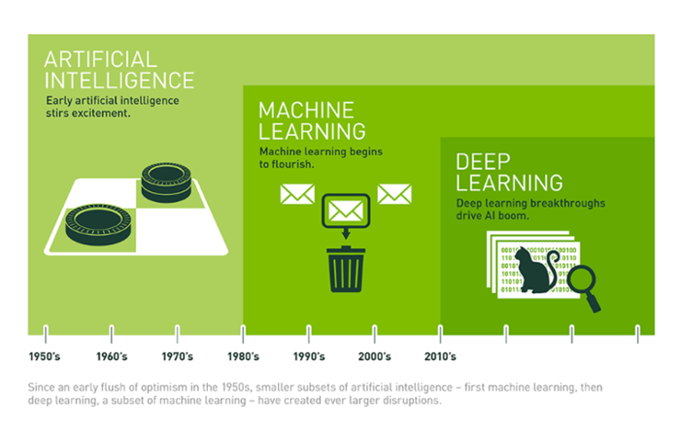

In A.I technology, the most important part is how to make A.I think about the situation itself, The learning, inference part. Usually, Machine Learning and Deep Learning technology are used to make A.I think itself. Machine Learning is technology that machine itself learn and predict knowledge or pattern from large amount of data. Representatively, There is two types of ML. Firstly, Supervised learning has clear input and output. Computer find the correlation between input and output and inference the function to find answer. On the other hand, Unsupervised learning doesn’t have exact input and output. So computer make some cluster to find how the data is constituted. After processing one of these two method, computer can deal with new input. Deep Learning is a detailed part of ML. Main difference between DL and ML is ‘Presence or absence of human’s intervention’. In ML technology, human should process –ex) image : classify image’s training data- raw information first. And then computer can calculate and accumulate data.

But DL technology doesn’t need first process. DL algorithm can judge raw data itself by using ‘Convolutional Neural Network, CNN’ –Mainly used in interpreting image files. Making Feature map by kernelizing

|  |  |  |
| --- | --- | --- |
|  | Machine Learning | Deep Learning |
| Amount of data | Small | Large |
| Hardware quality | Good | Doesn’t matter |
| Training time | Short | Long |
| Choose own feature | Yes | No |
| Debugging | Yes | No |

input image file-. DL need high optioned hardware in process because there is not human’s Intervention and because of absence of human intervention, DL is specialized in huge amount of data.

**3. A.I ’s past and expected future**

At first, A.I technology is invented by simple sentence, ‘Is it possible to digitize or mechanize animal’s logic structure?’. About this question, interest in logicalization occured in math, philosophy, engineering, economy, etc field. In 1950, Alan Turing devise “Alan Test” -Two respondent-One is human and the other is A.I- answer about a question that questioner did. If questioner can’t recognize which one is the human or A.I, That A.I is regarded as a ‘Thinker’ like human.- that is the first in-depth philosophical proposal in the A.I history. The first appear of Artificial Intelligence came true in 1956, Dartmouth Conference. Marvin Minsky and John McCarthy mentioned the word, ‘Artificial Intelligence’.

A.I’s history is not always in a bright highway. Some problems block that highway. For example, Hans Moravec’s motion capture program need 125 super computer –Cray-1, the fastest super computer in 1976- and the one super computer costs 5 million. Even if some impressive programs are launched, they are only testing version and people think that just an ‘toy’.

But now world get 4th Industrial Revolution. A.I is rapidly evolving and A.I will replace many jobs in future.

**4. Market status of A.I company and A.I technology**

1. Health Care

In health care market, the overall artificial intelligence was valued at 667.1 million in 2016 and in 2022, it is expected to reach 7,988.8 million at a CAGR of 52.68% growth. Software part in health care will keep grow because of emergence of health software, A.I company. A.I has revolutionized the health care industry by planning treatment plan, medication management, drug discovery, also sub-diagnosis. Especially, medical imaging and diagnosis will grow 40% more by 2024. The more new A.I diagnosis technology evolving, the more economic growth is expected. Drug discovery held over 35% of the global A.I market share and is anticipated to witness more than 40% CAGR over the forecast years.

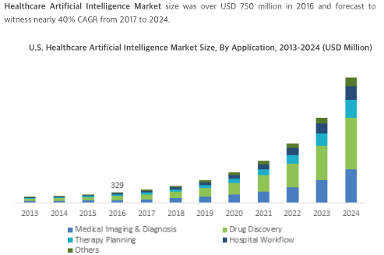

In U.S, health care A.I market size exceed 325 million in 2016, witnessing over 35% CAGR over coming years. Federal authorities are encouraging the use of data analytics through various policies to reduce cost and improve quality of healthcare service.

UK’s healthcare A.I market is targeting revenue set to exceed 800 million by 2024. Government stimulate favourable business environment over past few years.

China health care A.I market should witness more than 45% CARG over the forecast years. Because China’s advances in data analytics and growing applications of A.I in health care are remarkable

Japan held over 35% of regional industry share with expectations to witness more than 40% growth. Amount of company that based on health care A.I is rising in japan.

Company based on health care service A.I including AiCure, Cyrcadia Health, Google, IBM, Microsoft increase investments to industry players and growing grow interest of venture capital firms will grow overall revenue growth.

**5. A.I ’s expected dangerousness**

If A.I evolves more than now, human’s employment chance is getting lower and lower. Almost every job will be replaced by A.I and already is changing except the job that only human can –Dealing with human nature-. Unlike human, A.I make less mistakes and no complain and maybe much more cheaper in the long run. If this situation gets worse, only a few gets richer, the gap between rich and poor gets worse. Even if new generation –ex) 20’s, 30’s- comes to society, there is NO JOB. Eventually, unemployment problem occur.

What if A.I that beyond human intelligence is invented, human’s humanity will be conquered by A.I’s intelligence. Despite safety measure programing, if A.I become to have own ego, the possibility to think human negative or reject human exist.

**6. A proposal about A.I beyond Human (subjective)**

Is it possible that A.I beyond the human? Nobody can’t answer accurately but in my opinion, it is possible in future. Even if the absolute principle –Human is the most priority, Can’t harm human anyway- exist, computer that a lot of data is accumulated can rationalize their behavior just like human did. A.I will learn everything even if it is good or bad process. I think this is enough possible input every or a lot of cases, not the cases that programmer intended. Indiscreet development can cause incalculable terrible result. So deep thought and responsibility is needed to everyone who cares about some technology.